Current Practices of the Relinquishment of Property amongst Women in Kashmir: A Socio-legal Perspective
Dr. Syed Shahid Rashid∗
Dr. Shahnaz∗
Abstract
Denying women their rights to inheritance results in many socio-economic challenges and problems especially towards divorced women and widows. Besides express denials of their respective shares, there remains covert denial too. This includes relinquishment of share by woman in favour of male heir. This paper is an attempt to highlight the reasons underlying the practice of relinquishment of share. It further analysis its different dimensions and how this practice contributes to denial of property rights of women in Kashmir.

Introduction
Ensuring property rights of women remains cornerstone for their amelioration. However, so many challenges are attributed to this very right in the context of social, legal and familial paradigm. The Courts in India have also stressed on the significance of these rights. While emphasizing the vitality of property rights for the dignified life of woman, the Apex Court of India observed in Vineeta Sharma v. Rakesh Sharma:
“The right to dignified life is unachievable in reality unless it is backed by right to property. And if equality doctrine has to be telescoped into right to dignified life, then a man and a woman cannot have identical or substantially similar levels of dignified life unless both have certain right to property. Without economic freedom, it is futile to presume that a woman can enjoy her other personal rights effectively. While Article 15 of the Constitution grants women a right to equal opportunity, it is the economic security that ensures them a complete life under constitution.”
The right to inherit the property is one of the main forms of receiving property rights for women. Right to inherit opens up at the death of the owner of the property i.e. propositious. Since this law falls within the domain of Personal laws, every community in India is governed by the rules of own system of laws. Muslims in India are governed by the Shariat Application Act, 1937. This law, besides in other family matters allows Muslims in India to follow Shariat in the matters of inheritance. However, in Jammu and Kashmir customary law occupied inheritance matters on large scale as compared to other matters of family. These customs predominantly override the elaborate rules of Muslim law regarding inheritance. The customary laws governing Muslims in Jammu and Kashmir were repealed after the enactment of Jammu and Kashmir Shariat Act, 2007. Before the act, the application of Muslim Personal law was not only limited to certain matters but also subject to overriding effect of customs by virtue of Sri Pratab Jammu and Kashmir Laws Consolidation Act, (1977 Samvat Vikrami). With the abrogation of Article 370 by Parliament of India and enactment of J and K Reorganization Act, 2019 the erstwhile J and K stands bifurcated into two union territories i.e. J&K UT and Ladakh UT. With the result many local laws applicable to Jammu and Kashmir stand repealed now by virtue of Reorganization Act, and the Central laws are extended to Jammu and Kashmir. The Shairat (Application) Act, 1937 is one such legislation which is extended and applicable to Jammu and Kashmir and has replaced Jammu and Kashmir Muslim Personal Law (Shariat) Application Act, 2007.
Hypotheses
Relinquishment of share of inheritance by women in Kashmir is done under compulsion.
Research Methodology
The two-stage random sampling (purposive and simple random) has been adopted for the entire study. To meet the specific objectives, purposive sampling was employed to collect the information from the four districts of Kashmir i.e Srinagar, Budgam, Baramula & Anantnag. At second stage an ideal size of sample has been chosen by simple random sampling technique so that inferences from it could be drawn for the population. From the selected districts, 100 respondents (women) were taken from each district as sample size. Therefore, a total of 400 samples are selected randomly for the empirical study.

Empirical Analysis.
So far as right to inheritance of Muslim Women in Kashmir is concerned, they are governed by Islamic law of inheritance by the legislative intervention. Muslim Women is entitled to share of inheritance in various capacities i.e. widow, mother, sister, daughter, etc. However despite legislative interventions they face enormous challenges in acquiring their share of inheritance. They are often expressly denied the share by their brothers or other male or female relations. However, one important dimension of denial remains the relinquishment of share by women themselves in favour of their male siblings. Though they claim relinquishing their share voluntarily, however an in-depth analysis reveals that the relinquishment is done out of compulsion. The empirical analysis, results and discussions given below include different dimensions relating to the relinquishment of share of inheritance rights of Muslim women in Kashmir and factors therein.

Table 1: Category of Muslim women relinquishing share.
Title | Options | No.of Respondents | Percentage
Category of Muslim women who generally relinquished their share of the property? | Married Working Women | 251 | 63.0
 | Divorced | 60 | 15.0
 | Widows | 40 | 10.0
 | Unmarried Daughters | 49 | 12.0
 | Total | 400 | 100.0
Table 1 shows the category of women relinquishing their respective shares. 63% respondents believe that generally it is the working women who are married who generally relinquish their shares. 15% respondents believe that the divorced women relinquish their share, whereas 12% respondents opine that it is the unmarried daughters who relinquish their share. 10% respondents believed that widows only relinquish their share of property.

Table 2: Reasons for relinquishment by sisters in favour of their brothers.
Title | Options | No.of Respondents | Percentage
Sisters often relinquish their shares in favor of their brothers because of: | Social insecurity | 25 | 6.3
 | Love and affection | 92 | 23.0
 | Compulsion | 38 | 9.5
 | Don’t Want to Spoil Relation with Brother | 245 | 61.3
 | Total | 400 | 100.0
Table 2 represents the reasons for relinquishment of share by the sisters in favour of their brothers. The study reveals that 245 out of 400 i.e. 61.3% of total respondents feel that sisters relinquish (waive) their share in favor of their brothers just because they don’t want to strain their relations with them. 9.5% respondents believe that the relinquishment is done out of compulsion while as 6.3 % respondents believe that social insecurity is the reason of relinquishment. On the other hand 23 % of total respondents believe that relinquishment of share is done out of love and affection and there is no element of coercion or undue influence involved. This clearly indicates that 77% of women respondents believe that relinquishment of property is not done out of free will but due to factors which are compulsive. Sisters remain under this apprehension that incase of matrimonial disharmony, they have a cushion of brothers. The respondents feel that mostly the women (sisters in this case) are apprehensive that in case of taking their share, they have to snap their ties with their brothers which ultimately may close their access to their paternal home. So they don’t want to strain their relations with their brothers by taking their share which is otherwise due to them. Therefore, according to the study, the relinquishment remains another dimension of depriving women from inheriting their share
Table 3: Relationship of marital status and the relinquishment of share.
Title | Married Working Women | Divorced Women | Widows | Unmarried Daughters | All of them | Grand Total
Social insecurity | 16 | 7 | 0 | 2 | 0 | 25
Love and affection | 67 | 7 | 6 | 12 | 0 | 92
Compulsion | 14 | 8 | 11 | 2 | 3 | 38
Don’t Want to Spoil relation with Brother | 154 | 38 | 20 | 33 | 0 | 245
Total | 251 | 60 | 37 | 49 | 3 | 400
Pearson Chi-Square |  |  | Value |  | 62.809
 |  |  | Df |  | 12
 |  |  | Sig. |  | .000
Cramer's V |  |  | Value |  | .229
 |  |  | Sig. |  | .000
Since most of the respondents feel that the married working women mainly relinquish their shares (refer to table 1) one may assume that it is being done due to economic security. However, (table 3) reveals that 154 out of 251 respondents i.e. 61% support the view that married working women mostly relinquish their share just because they don’t want to spoil their relation with their brothers. This clearly indicates that even after marrying and earning themselves they stand compelled by a host of factors like their relationship with brothers, social insecurity and compulsion. Sisters do not want the doors of paternal home to be closed for them. It shows that they don’t take possession of their shares and instead relinquish by compelled circumstances. On the other hand, 67 respondents out of 251 i.e 27% believe that the married working women relinquish their share on the basis of love and affection. The data further reveals that 38 out of 60 respondents (those who believe that divorced women relinquish) i.e. 63.3% opine that divorced sisters equally relinquish due to the apprehension that their relation with brothers should not be spoiled in any case. Whereas only 11.6% respondents (out of 60 only) opine that divorced women relinquishes out of love and affection. Amongst those respondents who believe widows relinquish 20 out of 37 i.e. 54% consider that relinquishment of share is made just because they don’t want to spoil their relations with the brothers. Whereas 16.2% respondents observe that it is done out of love and affection. Amongst 49 respondents (i.e those who support this view that unmarried daughters relinquish) 33 respondents i.e. 67.3% feel that they relinquish just because they don’t want to spoil their relation with brothers. On the other hand, 24% respondents feel that unmarried daughters relinquish out of the love and affection. This clearly indicates that irrespective of their marital status, the women relinquish their shares to avoid spoiling their relationship with brothers.
The reasons for relinquishment of share of inheritance are further analyzed in relation with key indicators like area, profession, income and marital status.

Table 4: Reasons of relinquishment by sisters with respect to area.
Areas | Don't Want to Spoil their Relationship with Brothers | Out of Compulsion | Out of Love & Affection | Social Insecurity | Grand Total
Rural | 183 | 34 | 60 | 21 | 298
Urban | 62 | 4 | 32 | 4 | 102
Total | 245 | 38 | 92 | 25 | 400

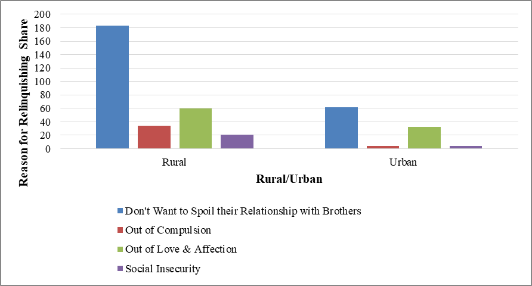

Figure 1
Table 4 reflects that in rural areas, 61% respondents believe that sisters do not want to spoil their relationship with brothers and due to this reason they relinquish their share. Whereas 20% respondents in rural areas consider love and affection as the main reason for relinquishment of share. On the other hand in urban areas 60.78% respondents consider that sisters don’t want to spoil their relationship with brothers due to this reason they relinquish their share. 31% respondents in urban areas consider love and affection as the reason for relinquishment. Therefore, the reasons of relinquishment are universal as per the study.
Table 5: Reasons of relinquishment by sisters with respect to profession.
Profession | Don't Want to Spoil their Relationship with Brothers | Out of Compulsion | Out of Love & Affection | Social Insecurity | Grand Total
Housewife | 73 | 22 | 32 | 9 | 136
Student | 83 | 7 | 29 | 6 | 125
Working (Job) | 89 | 9 | 31 | 10 | 139
Total | 245 | 38 | 92 | 25 | 400

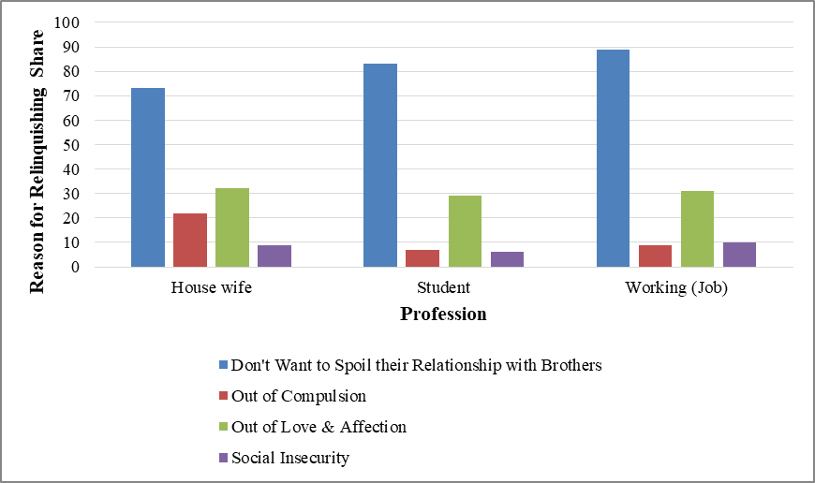

Figure 2
Table 5 reflects that 53.6% respondents who are house wives consider that sisters do not want to spoil their relation with brothers and they relinquish their share in favour of brothers. With regard to the same reason the percentage of those respondents who are students and the working women is 66.4% and 64.02% respectively. Considering love and affection as the reason for relinquishment of share the percentage of respondents’ profession wise stands as: House wife 23%; Students 23%; Working females 22.3% respectively.
Table 6 : Reasons of relinquishment by sisters with respect to income.
Income | Don't Want to Spoil their Relationship with Brothers | Out of Compulsion | Out of Love & Affection | Social Insecurity | Grand Total
High | 19 | 6 | 4 | 0 | 29
Lower | 33 | 8 | 12 | 2 | 55
Middle | 193 | 24 | 76 | 23 | 316
Total | 245 | 38 | 92 | 25 | 400
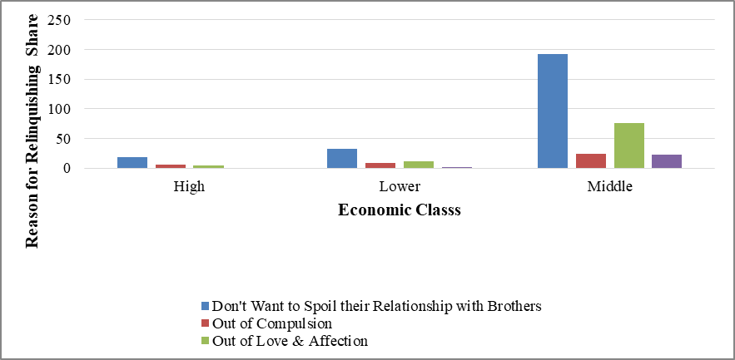

Figure 3
Tab. 6 reflects that 65% of the respondents belonging to a higher income group, 60% belonging to lower income group and 61.07% belonging to middle income group consider that sisters relinquish their share in favour of brothers just because they don’t want to spoil their relation with them. On the other hand, 14% respondents belonging to higher income group, 21.8% respondents belonging to lower income group and 24.05% respondents belonging to middle income group consider love and affection as the main reason for relinquishment of share in favour of brother.

Table 7: Reasons of relinquishment by sisters with respect to marital status.
Marital Status | Don't Want to Spoil their Relationship with Brothers | Out of Compulsion | Out of Love & Affection | Social Insecurity | Grand Total
Divorced | 9 | 13 | 2 | 0 | 24
Married | 109 | 16 | 47 | 10 | 182
Unmarried | 88 | 4 | 29 | 5 | 126
Widow | 39 | 5 | 14 | 10 | 68
Total | 245 | 38 | 92 | 25 | 400

Figure 4
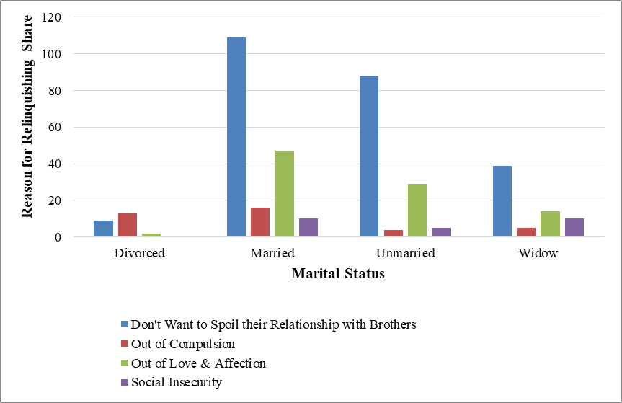

Table 7 reveals the status of relinquishment vis-à-vis marital status. In this regard 37% of divorced respondents, 60% of married respondents, 70% of unmarried respondents, 57% of widow respondents believe that the sisters relinquish their share in favour of brothers because they don’t want to spoil their relation with them. On the other hand, 8.3% of divorced respondents, 26% of married respondents, 23% of unmarried respondents, 20.6% widow respondents consider that sisters relinquish their share in favour of brothers out of love and affection. 5.4% of married respondents and 14% of widow respondents consider social insecurity as the main reason for relinquishment of share. Therefore, it is established from the above table that majority of women irrespective of their marital status relinquish their shares of inheritance in favour of their brothers primarily to maintain a cordial relationship with them.
However, it was also found during study that the ‘separated women’ are more indecisive about relinquishing their share of inheritance in favour of brothers. This is primarily due to uncertainty about the continuity of the marriage.
Table 8: Relinquishment by Brothers
Title | Options | No. of respondents | Percentage
Do brothers too relinquish their shares of inheritance in favor of sisters? | Yes | 73 | 18.0
 | No | 327 | 82.0
 | Total | 400 | 100.0
Table 8 reveals that 82% of total respondents consider that brothers generally do not relinquish their share in favour of sisters. 18% respondents agree that brothers too relinquish their share to sisters. This shows that it is the sisters who mostly relinquish their share in favour of brothers and not vice-versa.

Conclusion and Findings
It was found that relinquishment remains another way of depriving women from inheriting property. Women are forced to relinquish their share of property in favour of other legal heirs, particularly brothers. The summarized positon in this regard is given as under:
- 77% of women believe that relinquishment of property is not done out of free will, rather the compulsions are manifold which prompt sisters to relinquish their share in favor of the brothers.
- According to 63% women, married working women mostly relinquish their share.
- The study reveals that 61% women support this view that married working woman mostly relinquish their share because of the reason that they don’t want to spoil their relation with brothers. This shows that even after marrying and earning themselves they are compelled by a host of factors like their relationship with brothers, social insecurity and compulsion.
- 15% respondents believe that divorced women relinquish their share, whereas 12% respondents opine that unmarried daughters relinquish their share. 10% respondents consider that it is only the widows who relinquish their share of inheritance.
- 65% of the respondents belonging to a higher income group, 60% belonging to lower income group and 61.07% belonging to middle income group consider that sisters relinquish their share in favour of brothers just because they don’t want to spoil their relation with them.
- 53.6% respondents who are house wives consider that sisters do not want to spoil their relation with brothers and they relinquish their share in favour of brothers. With regard to the same reason the percentage of those respondents who are students and the working women is 66.4% and 64.02% respectively.
- 82% of total respondents consider that brothers generally do not relinquish their share in favour of sisters.
It can be concluded that irrespective of the socio-economic profile, the majority of women in Kashmir are compelled by various factors like relationship with brothers, social insecurity and compulsion to relinquish their share of inheritance in favour of male heirs. Sisters remain under this apprehension that incase of matrimonial disharmony they have no place to go; they have a cushion of brothers only. So they don’t ordinarily want to spoil their relation with the brothers by claiming their share of inheritance. In this way, relinquishment of share in favour of male heirs has taken deep roots in the society from one generation to the next which needs immediate legislative intervention. Therefore, in such scenario relinquishment process needs to be regulated by law. Inheritance and succession matters pertaining to properties also involve revenue officials like patwari and tehsildars for the purpose of mutation of legal heirs or verification of the same. Therefore, the role of revenue officials in ensuring smooth devolution of property remains very significant. It is pertinent to mention that the main element in the entire process is correct information that shall reach a patwari through concerned field official i.e Lumberdar. During the study, it was found that women often change their freewill during the time of attestation of mutation and they are more eager to relinquish than to take their share probably because of family or social pressure. Thus in such scenario all the legal heir’s presence in person during attestation of mutation shall be made mandatory in order to ascertain whether any legal heir is in possession of any document that can affect devolution of inherited property.

 Assistant Professor, Kashmir Law College, Nowshera Srinagar.
 ∗ Associate Professor, School of Law, University of Kashmir.
AIR 2024 SC
Section 2 and 3 of the Act of 2007
By Virtue of Article 370 Jammu and Kashmir had special status within the Constitution of India i.e. Parliament of India was competent to frame laws for the J and K regarding three matters: Defence, Foreign Affairs and Communication. Rest all the matters were within the competence of Jammu and Kashmir Legislative Assembly.
Act 34 of 2019, s. 95 and the fifth schedule (w.e.f. 31-10-2019).
The Shariat Application Act, 1937 (formerly The Jammu and Kashmir Shairat Act, 2007)
Who have not been formally divorced and are living separately.

